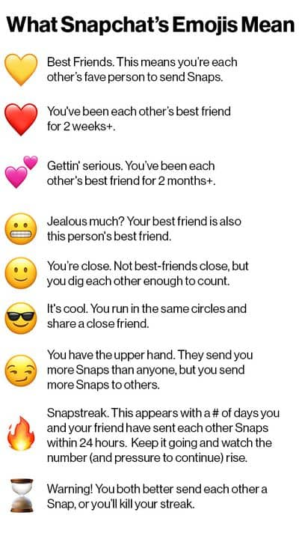
Requirements:
- Both people have to ‘send’ a pic with text at least once a day (24hrs).
- ‘Streak’ must last 15 days minimum. (30 posts total).
- Must use at least two emojis.
- Text must be short (no more than the max for SnapChat) but related to the text/characters/plot/theme.
- ‘Streak’ must show that you read and understood the text.
- You can choose to have two characters chat or you and another student chat.
- Create your ‘Streak’ in a Word document, PowerPoint Presentation, or PDF.
- Include a response to the “Why this book? Why not this book?” question.
  - This can be in the streak or as a separate slide or paragraph.

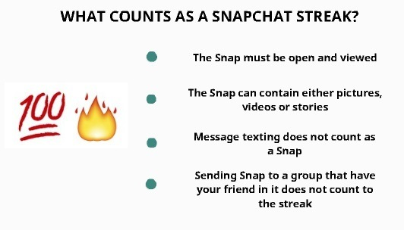
In fact, only one type of content will help you get you credit for your Snapchat streak: sending a photo with text to a character/ friend individually.

