As you are reading your summer reading book, you have different choices for doing a project to show your understanding of the book you are reading. One of those options is a Twitter conversation between yourself and a character or two or three different characters in the book. You will need to have at least 5 tweets a piece between two characters, slightly less if there are more than 2 characters making comments. You will need ot show a total of three conversations through the course of the book. These should be done at different points in the book and may be done between different characters each time.

An example of you and a character having a conversation may be that a character asks a question out into the universe and you give them advice, you and character will exchange 5 tweets each about the situation and the advice. You give them.
Another option is that several characters gather online to talk about what is going on in the story at a specific point. Each character will interact, and they will discuss what is going on in the story and you will use your knowledge of the characters to craft their responses. Examples of such conversations are below. These conversations are based on characters from Pride and Prejudice.

Your characters’ conversations will not be done on actual platform as teachers cannot chase down social media accounts every student would create, so you will create your conversation on a word document, paper or other method of recording the conversation. You will need to have a more in depth conversation than “Hey, what’s good” “nothing” “have you seen __ character’s name around?”
Your tweets should include plot points and important moments that the characters may want to discuss, come back to, or understand better. They can include status updates that another character comments on. As you can see here in the examples, some conversations are between just two characters, such as the first two examples, the third example shows a status update that others comment on, you would of course make more comments on your version, and the fourth example shows three characters having a conversation together. The fifth example is one where a character is asking advice, if you did a version similar to this you’d need comments giving advice either from you the student directly, or from other people in the story. Having minor characters bring in ideas for a tweet like this may be a smart idea as their view of the situation might be different than other characters.
The last example is a non-example and it is described why on top of that picture.

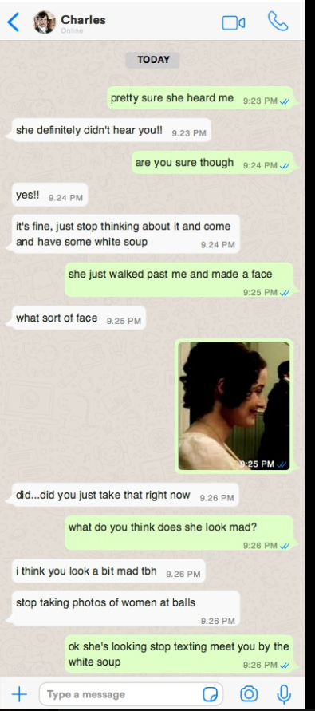
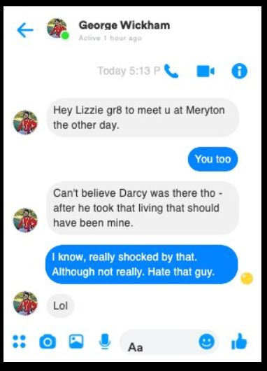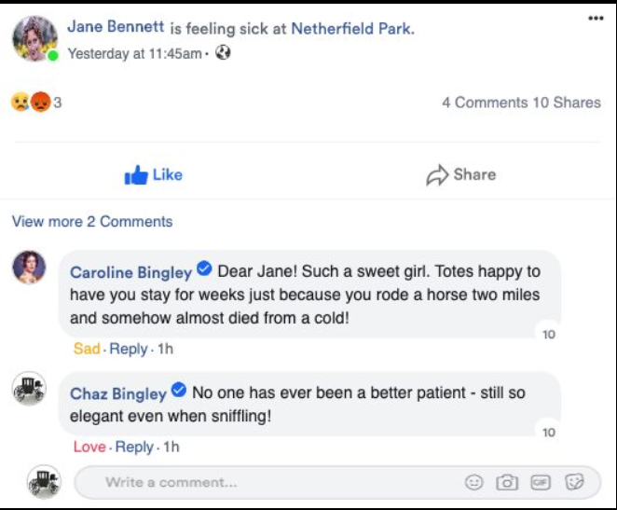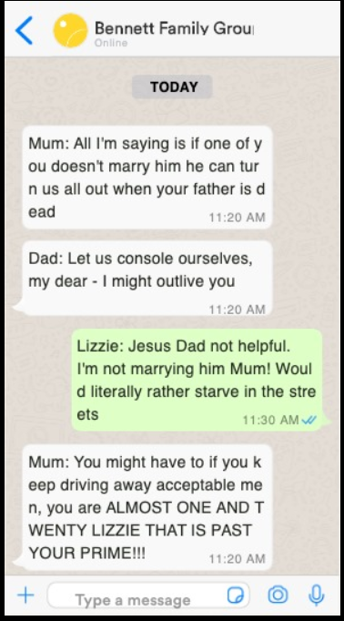
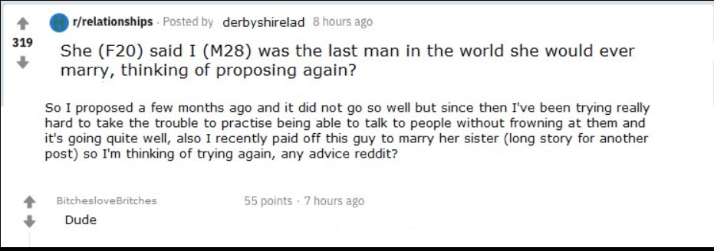

This is an example of a non-example, the plot point being discussed is not particularly important and does not really further the story along. It doesn’t tell us much about the characters or their views on what is going on in the story.
